Milk Supply Area and Revenue Analysis Dashboard
Pradnya .S. Patil
diuupatil9890@gmail.com
R. C. Patel College Of Engineering And Polytechnic

Abstract :
This research focuses on the development and implementation of a Milk Supply Area and Revenue Analysis Dashboard to provide a comprehensive and data-driven understanding of milk distribution and financial performance across different geographic regions. The dashboard systematically collects and processes milk supply data from multiple locations, enabling the identification of milk-providing areas and the quantification of their contribution in terms of volume percentage. In addition, it integrates revenue data to evaluate the monetary value generated by each area, offering a clear correlation between milk supply quantity and economic return.
Advanced data visualization techniques are used to present key performance indicators such as area-wise milk contribution, percentage distribution, total revenue, and comparative regional performance. The dashboard allows stakeholders to easily monitor trends, identify high-performing and low-performing areas, and detect imbalances or inefficiencies in the milk supply chain. By transforming raw data into meaningful visual insights, the system supports better planning, pricing strategies, resource allocation, and operational decision-making.
The proposed dashboard enhances transparency and efficiency in dairy supply management by enabling real-time or periodic analysis of supply and revenue patterns. It serves as a valuable decision-support tool for dairy cooperatives, milk collection centers, and management authorities to optimize distribution networks, improve profitability, and ensure sustainable growth of the dairy industry.

Keywords:
Milk Supply Analysis, Revenue Analysis, Dashboard, Data Visualization, Dairy Industry, Supply Chain Management

Objective:
- To compile and structure the data related to milk procurement from various geographic regions
2. To identify the regions that supply milk and determine their share in the total supply of milk
3. To determine the percentage-wise distribution of milk supply from various regions
4. To determine the revenue generated from milk supply in various regions
5. To develop an interactive dashboard for the representation of data
6. To facilitate effective planning and decision-making in dairy supply chain management

Introduction:
The Milk Supply Area and Revenue Analysis Dashboard gives a complete overview of milk procurement and sales performance for various milk supply areas. The dashboard helps users track milk supply volumes, analyze revenue performance, and compare regional performance. The dashboard combines milk supply data with revenue data to facilitate decision-making and enable users to identify areas of excellence and areas of poor performance to optimize supply chain efficiency and profitability.

Data Collection:
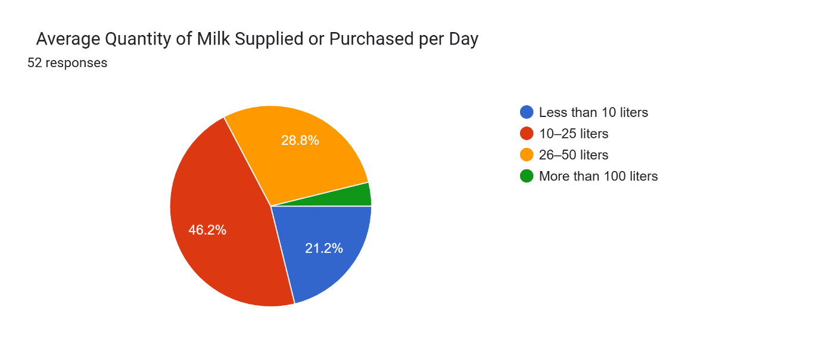
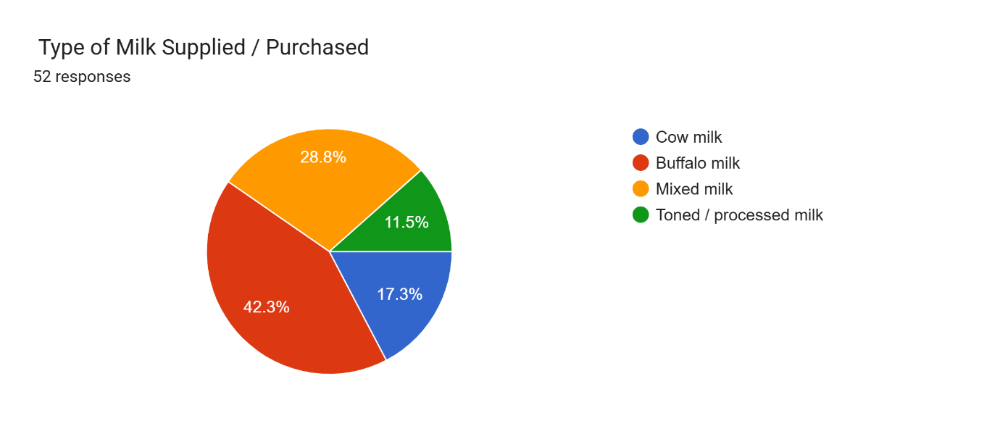
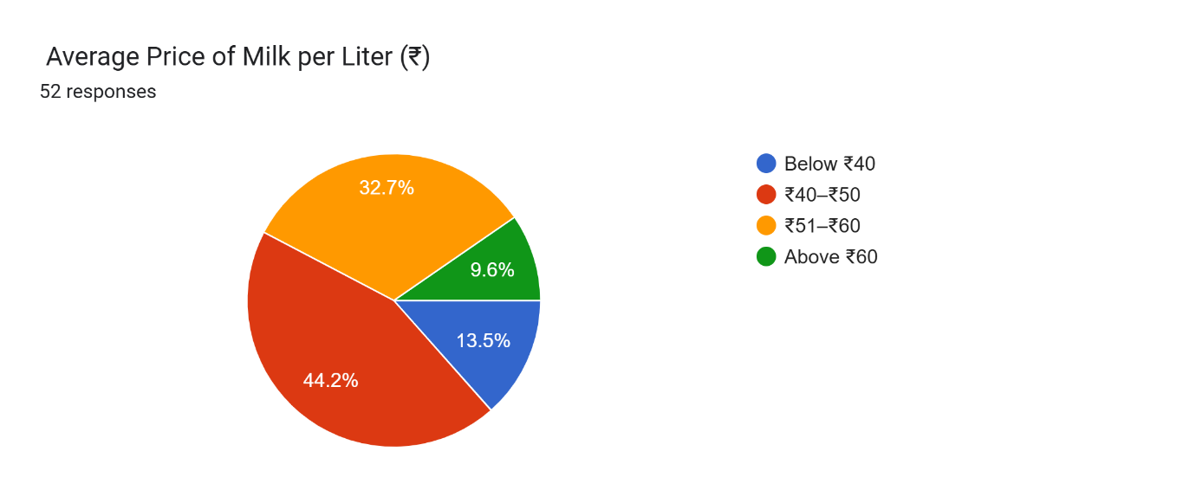
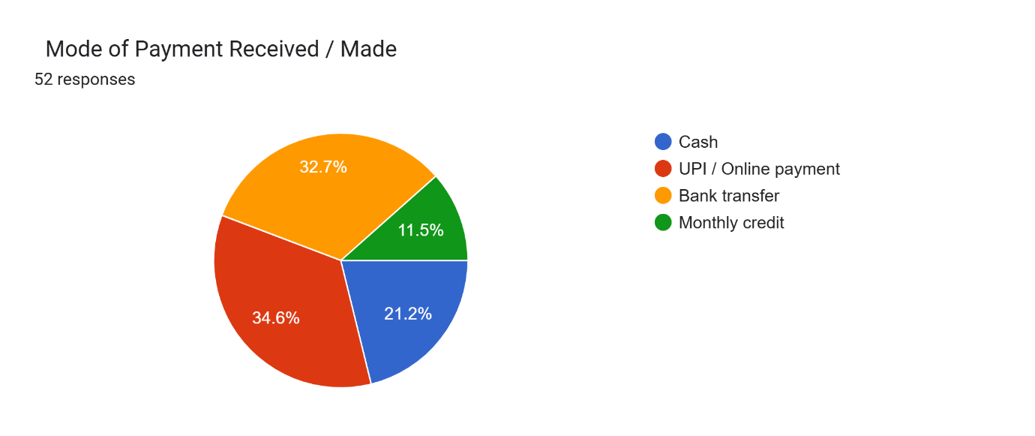

Hypothesis:

H1: Average Quantity of Milk Supplied or Purchased per Day
Sr. No. | Options | Oi | Ei | Oi-Ei | (Oi-Ei)² | (Oi-Ei)²/Ei
1 | Less than 10 liters | 11 | 13 | -2 | 4 | 0.30
2 | 10–25 liters | 24 | 13 | 11 | 121 | 9.30
3 | 26–50 liters | 15 | 13 | 2 | 4 | 0.30
4 | More than 100 liters | 2 | 13 | -11 | 121 | 9.30
Total |  | 52 |  |  |  | 18.9

€(Oi-Ei)²/Ei = 18.9
Degree of Freedom is 5.991.
Result = 18.9 > 5.991.

H2. Average Price of Milk per Liter (₹)
Sr. No. | Options | Oi | Ei | Oi-Ei | (Oi-Ei)² | (Oi-Ei)²/Ei
1 | ₹40–₹50 | 23 | 13 | 10 | 100 | 7.69
2 | ₹51–₹60 | 17 | 13 | 4 | 16 | 1.23
3 | Below ₹40 | 7 | 13 | -6 | 36 | 2.76
4 | Above ₹60 | 5 | 13 | -8 | 64 | 4.92
Total |  | 52 |  |  |  | 16.6

€(Oi-Ei)²/Ei = 16.6
Degree of Freedom is 5.991.
Result = 16.6 > 5.991.

Conclusion:
The Milk Supply Area and Revenue Analysis Dashboard is a successful example of how data analysis can be used to enhance efficiency and effectiveness in dairy supply chain management. By collecting and analyzing the data related to milk procurement from different geographical regions, the study has been able to identify material differences in the quantity of milk supply as well as the differences in the pricing trends. The chi-square hypothesis test has further validated that these differences are statistically significant.
The dashboard has been able to combine the data related to supply volume and revenue, which helps the user to understand the contribution, percentage, and performance of the different areas in an effective and interactive way.

References:
1.Data Science for Business - Foster Provost & Tom Fawcett, O’ Reilly Media,2013. (Concepts of data -driven decision making and business analytic )
2.Storytelling with Data - Cole Nussbaumer Knaflic , Wiley,2015. ( Data Visualization and dashboard design principles.)
3.Business Intelligence Guidebook - Rich Sherman , Morgan Kaufmaan ,2014. ( Business Intelligence and dashboard implementation concepts.)
4.National Dairy Development Board - Official reports and Dairy Statistics , Government of India. ( Milk Protection and Supply data references )
5.Food and Agriculture Organization (FAO), Dairy Market Review Reports. ( Global Dairy production and revenue insights )
6.Microsoft Power BI Documentation - Microsoft Learn. (For Dashboard Development and data Visualization technique .)

